Name: Andrea Masongo Bw’Omondi
BCS
Reg No: C024/402058/2023
HTTP Header Analysis Report.
-Use of a network packet sniffer; wireshark, to analyze HTTP headers.

Capture an HTTP GET and POST request:
HTTP GET:
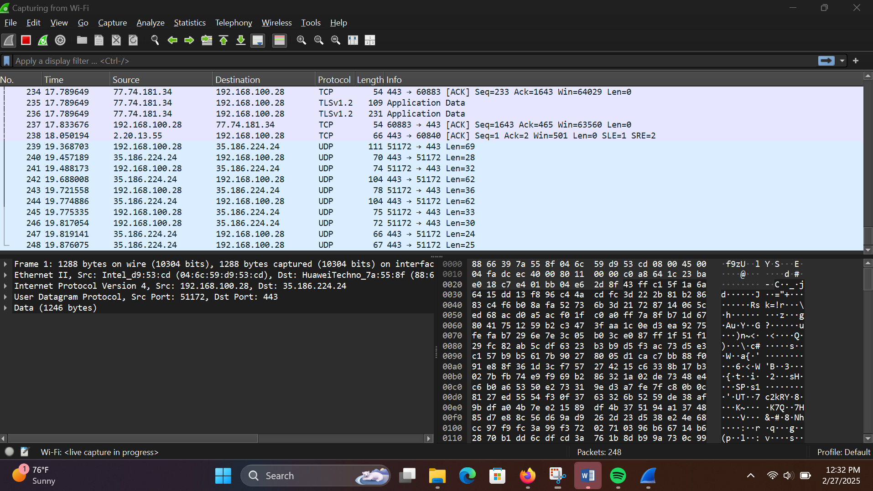
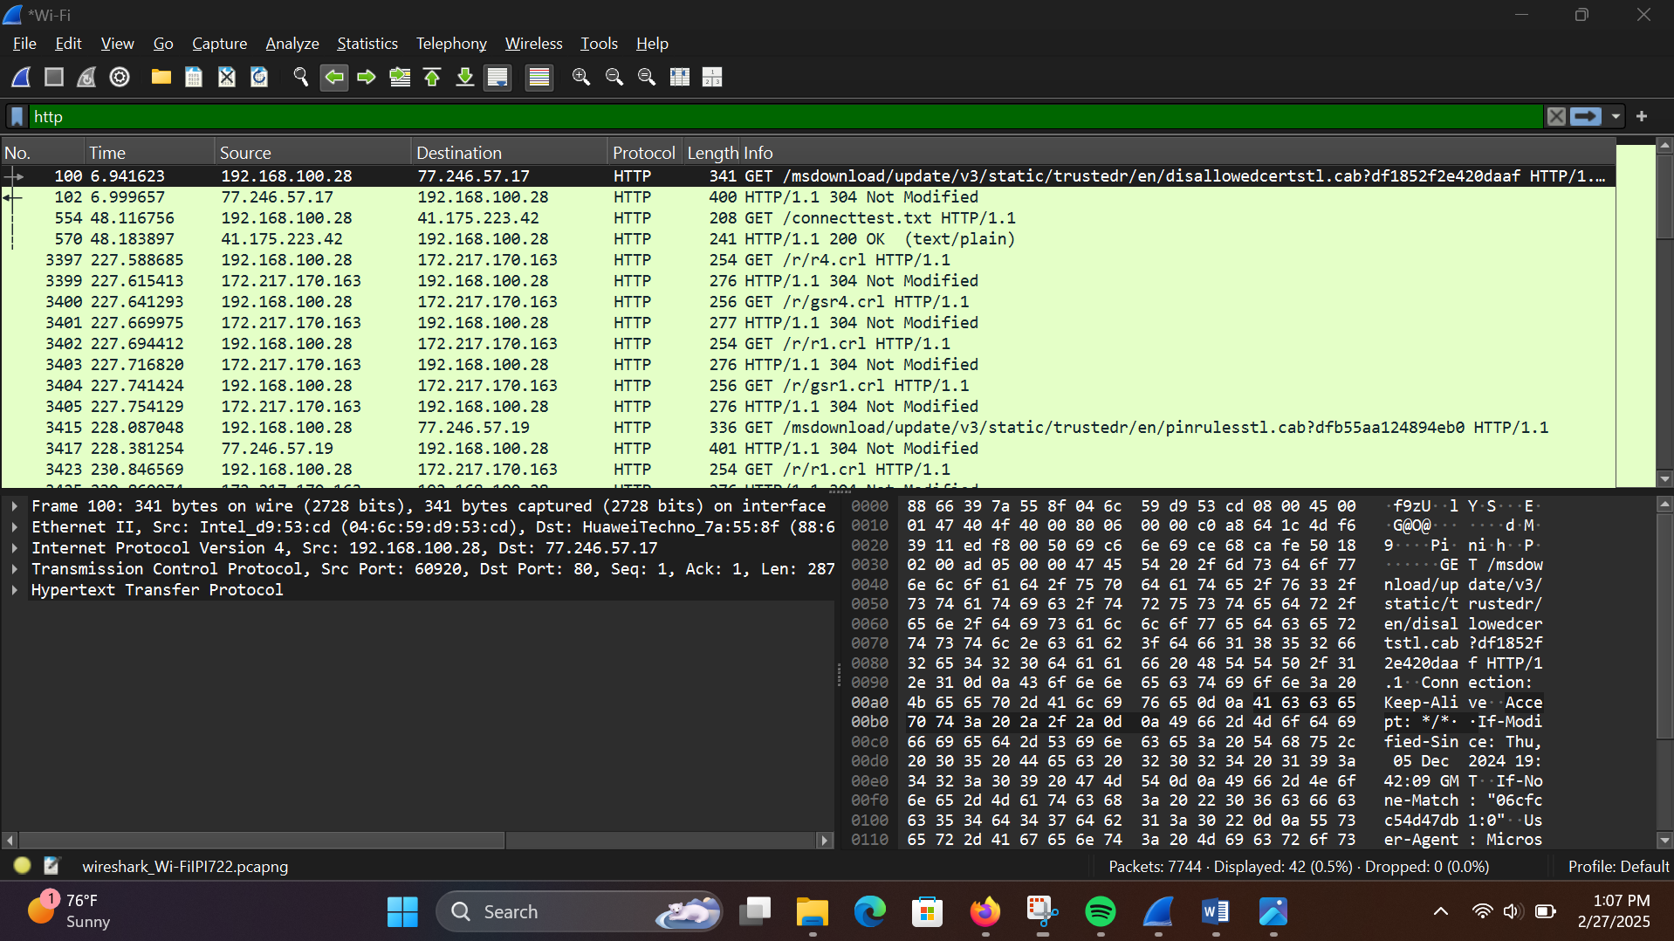
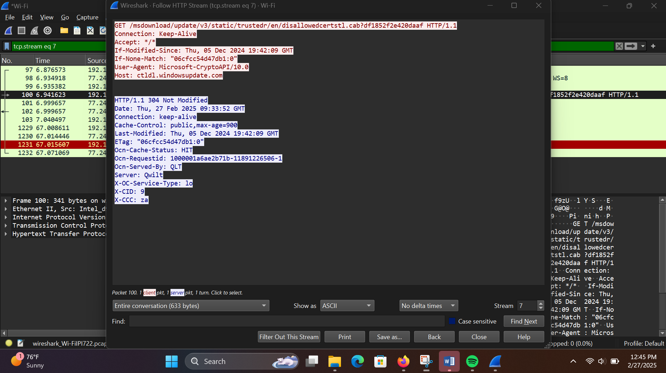

Header Identification:
Request headers:
GET /msdownload/update/v3/static/trustedr/en/disallowedcertstl.cab?df1852f2e420daaf HTTP/1.1
Host: ctldl.windowsupdate.com
User-Agent: Microsoft-CryptoAPI/10.0
Accept: */*
Response Headers:
HTTP/1.1 304 Not Modified
Server: Qwilt

HTTP POST:
